RAMOTSILISI. NTSHINGILA.MOKOENA

2012168478.2014214064.2014201020

usecase and Quotation together with non-extractions

Team Project

# Use Cases

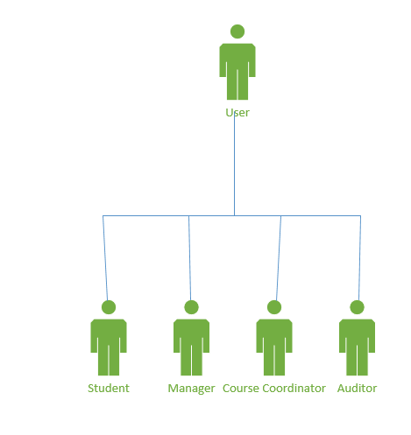

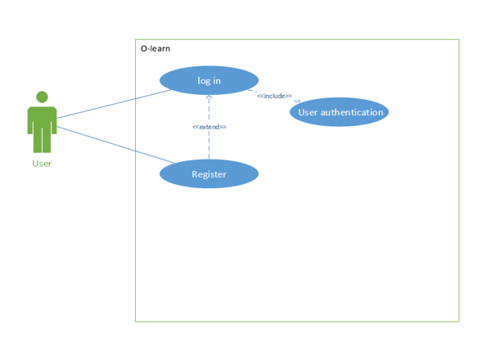

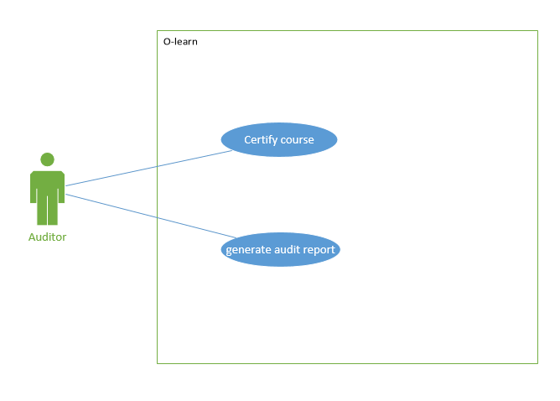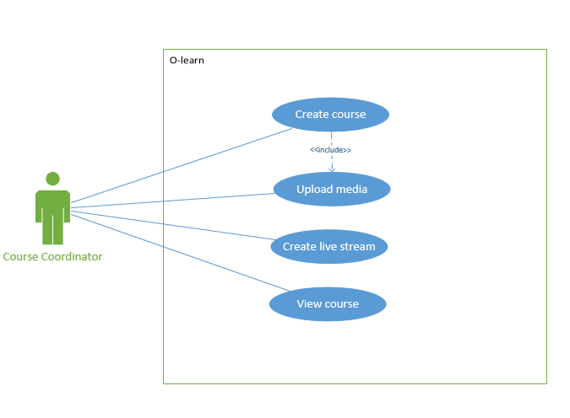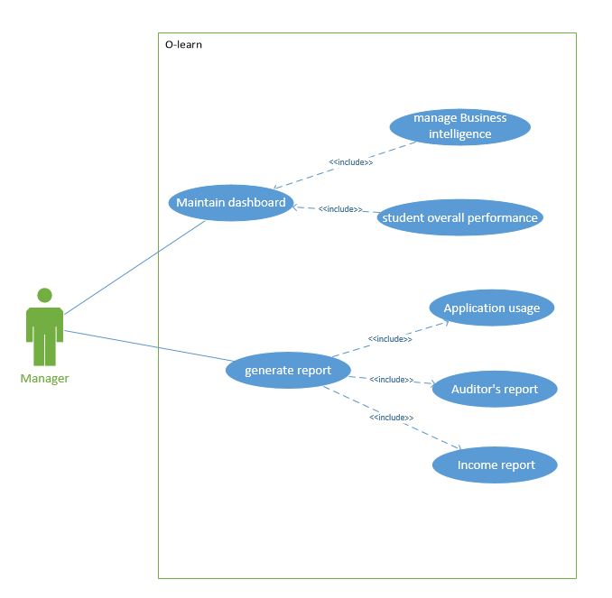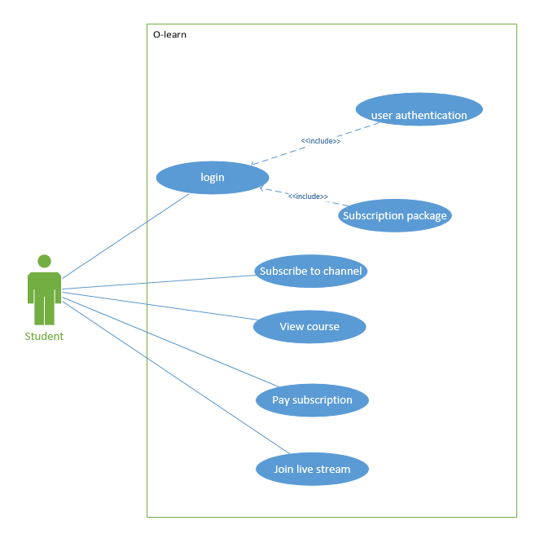

## USER-LOGIN

DESCRIBTION

The user needs to login before to the website before view the course or doing anything.

Normal Scenario

Steps

1. The user opens the webpage
2. The system opens the login page
3. The user put in his\her credentials correctly
4. Than the user presses the login button
5. The user has successfully login

Best Scenario

Steps

1. The user opens the webpage
2. The system opens the login page
3. The user uses a single source to login
4. The user provides his\her username
5. The system retrieves the user password

Worse Scenario

Steps

1. The user opens the webpage
2. The system opens the login page
3. The user provides his\her credential correctly
4. The system gives the message saying wrong credentials
5. The user must restart the device
6. The do the whole process

## USER-SUBSCRIBE TO CHANNEL

DESCRIBTION

The user needs to subscribe to the channel before watching videos and listening to audios. The user need to pay for subscription.

Normal Scenario

Steps

1. The user opens the desired channel
2. Channel is loaded on the screen
3. The user subscribes to the channel
4. The user presses the desired media button
5. User goes to the video or audios
6. The user listens to audios or watch videos
7. Once the user is done
8. The user closes the tab
9. System closes

Best Scenario

1. The user opens the desired channel
2. System loaded the channel’s screen
3. the user subscribes to the channel
4. The user presses the desired media button
5. User listens or watch media
6. The channel gives the user option
7. To replay
8. Choose from the same media but different
9. Change the media
10. the user closes the channel tab

Worse Scenario

Steps

1. User opens the channel
2. The system loads the channel’s screen
3. The user presses the desired media button
4. User does not listen and watch media given
5. Subscribes, leaves remarks
6. Never pays

## USER PAYS FOR A SUBSCRIPTION

BRIEF DESCRIPTIONS

User pays for the subscription package they subscribed to

Normal Scenario

Steps

1. User clicks on pay subscription tab.
2. Subscription activity is loaded on the user screen
3. User click pay subscriptions
4. A list of payments methods are presented to the user.
5. User select the certain amount for her/his choice of payment
6. User enters their details
7. Transaction is processed.

Worse Scenario

Steps

1. User Click on payment subscription tab
2. Subscription activity is loaded on the screen of the user
3. User click the payment methods that is above her/his payments
4. User select the wrong amount
5. User details said to be incorrect.
6. The transaction cannot be processed

## USER-JOIN LIVE STREAM

DESCRIPTION

The user should join the live streams created by the course coordinator to extra classes

Normal Scenario

Steps

1. the user opens the e-learn
2. the system loads the e-lean page
3. the user chooses the join live scream category
4. the system loads the join live scream
5. the user joins the live screams
6. the user is engaged to the live screams topic
7. the user can give suggestions or comments on the given topics
8. the user closes the live scream page

Best Scenario

Steps

1. User click on desired course
2. Course is loaded on the user screen
3. User click join live stream class
4. User is added to the class

Worse Scenario

Steps

1. User click on desired course
2. Course is not loaded not found
3. User cannot continues.

## COURSE COORDINATOR-CREATE COURSE

## COURSE COORDINATOR-UPLOAD MEDIA

DESCRIPTION

The course coordinator upload media including documents and solution file

So that the file reaches the user

Normal Scenario

Steps

1. The course coordinator opens the e-learn page
2. The course coordinator login into the e-learn
3. The course coordinator presses upload button
4. The course coordinator uploads what It been approved by the manager
5. The system loads the uploads
6. The student views what is uploaded
7. The course coordinator closes the e-learn

## COURSE COORDINATOR-CREATE LIVE STREAM

DESCRIPTION

The course coordinator creates a live stream platform where he\she post some concept to be discussed and will be conducted by the course coordinator.

Normal Scenario

Steps

1. The course coordinator opens the e-learn
2. System loads the page
3. The course coordinator login
4. The course coordinator chooses the create live scream block
5. The system loads the create live scream page
6. The course coordinator creates the live scream
7. The course coordinator post the topic to be covered
8. The course coordinator logout

## AUDITOR-CERTIFY COURSE

DESCRIPTION

The auditor certifies the course by checking the quality of the materials before it presented to the user to maintain the university standard

Normal Scenario

Steps

1. The auditor downloads what the course coordinator has sent him\her
2. The system downloads the files
3. The auditor views the documents
4. The auditor reads the documents
5. The auditor comment where necessary, recommends changes where applicable
6. The auditor sends the feedback back to the course coordinator

Best Scenario

Steps

1. Auditor select course for auditing
2. Course is viewed to the auditor
3. Auditor checks course
4. Auditor gives feedback on course audited
5. Auditor sends back feedback to the course coordinator.

## AUDITOR GENERATE AUDIT REPORT

DESCRIPTIONS

Auditor generates audit report for the manger.

Steps

1. Auditor sums up the annual student performance
2. Auditor gives suggestion for the course
3. Auditor sends back report.

## MANAGER MAINTAIN DASHBOARD

DESCRIPTION

The manager should maintain the dashboard by updating the overall performance course for each user and sum up all added and edited marks, keep track of videos watched, to be watched and maintain the insights.

Normal Scenario

Steps

1. The course coordinator uploads marks
2. The system update marks from the previous marks and adding them to the new mark and calculating the overall mark
3. The manager then updates all the users marks
4. The system keeps track of user’s course progress
5. System display relevant information to relevant students
6. System shows business intelligence to users

## MANAGER GENERATES REPORT

DESCRIPTIONS

Manager generates a series of reports related to the usage of the application, auditors report an income report.

Steps

1. manger sums up the income for the given period
2. manager verifies auditors report
3. using application monitor software manger generates application usage report

# QUOTATION PROJECT

R240 per hour

5% of total hours, general expense

R8000 + 14% software cost

6 hours each day for 5 days a week for 2 months

R240 x 6 hours = R1440

R1440 x 5 days = R7200

R7200 x 8 weeks = R288 000

5% of R288 000 = R14 400 for general expenses (transport, water bill, printing and electricity)

R8000 + 14% = R9120 (software costs)

Total estimation = R288 000 + R14 440 + R9 120 = R311,520

Requirements:

Interviews: R4320 (18 man hours)

Data gathering: R2880 (12 man hours)

Meetings: R5280 (22 man hours)

Printing: R400

Transportation: R1800

Analysis:

Data analysing: R7200 (30 man hours)

Transportation: R600

Design:

Designing: R8640 (36 man hours)

Implementation:

Coding: R21600 (90 man hours)

Testing: R7200 (30 man hours)

Post-delivery maintenance:

Maintenance: R115 200 (480 man hours)

Retirement:

Not applicable.

Total workflow cost: R175 120

Total = 240 man hours’ x 3 team members = 720 working hours

Total cost: R57600 x 3 = R172 800

Total product cost: R172 800 + R175 120 = R347 920.00

## NOUN EXTRACTION

### Step 1: Define the concise problem

The University of the Free State’s Centre of teaching and learning (CTL) requires the developments of an online learning platform. the application is for qualified academics of information Technology topics. This application should accommodate mobile devices and desktops. The course coordinator should create courses as to uploads media, documents and solution files which should be certified and quality checked by the manager before it uploaded to the application. Students must subscribe to the service and pay for packages either a monthly, three months, 12-month payment. The application should have a login page which will check for authentication of the student. The application should also provide live screams are virtual classroom, where a lecture can presence in real time. It should also provide student dashboard where student’s performance is kept and media used.

## Step 2. Identify the nouns

Mobile device, desktop - lie outside the problem boundary and therefore may be ignored

Online, Information Technology, Service, Quality, academics, authentication – Are Abstract nouns (They identify things that have no physical existence)

Course Coordinator, Student, Payment, Dashboard– Can be use as candidate classes.

candidate classes

Device class, login class, course class, course coordinator class, media upload class, subscription class, payment class, student class, dashboard class

Subclasses

subscription package class, Device authentication class

Noun extraction class diagram

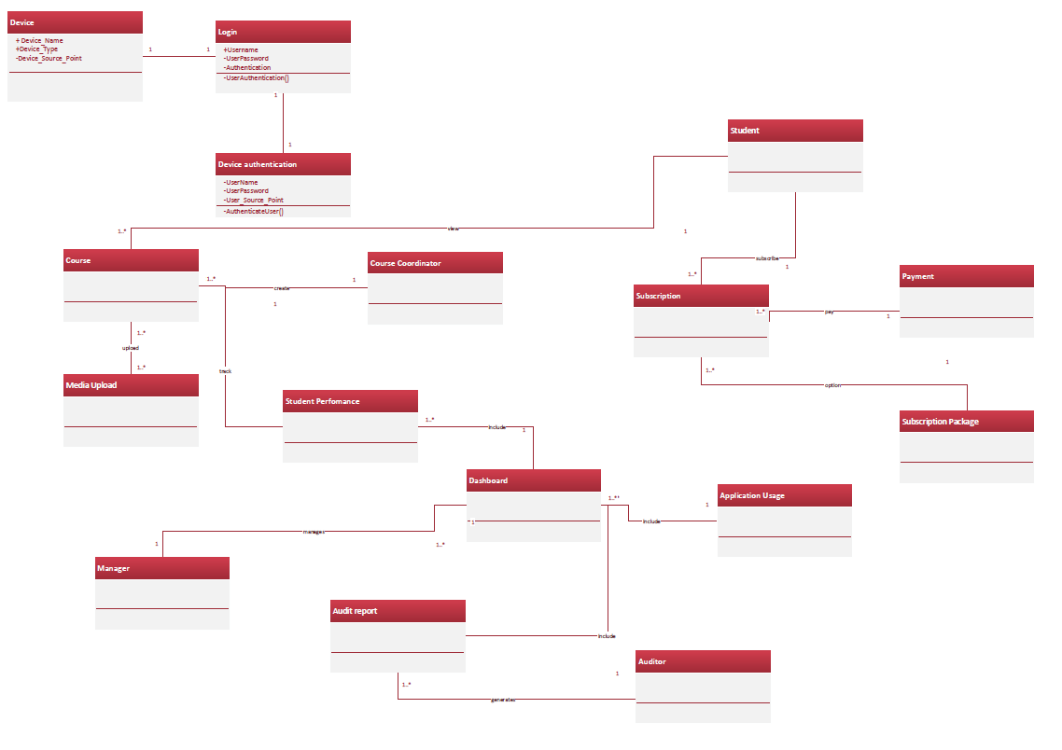

# Communication Diagram

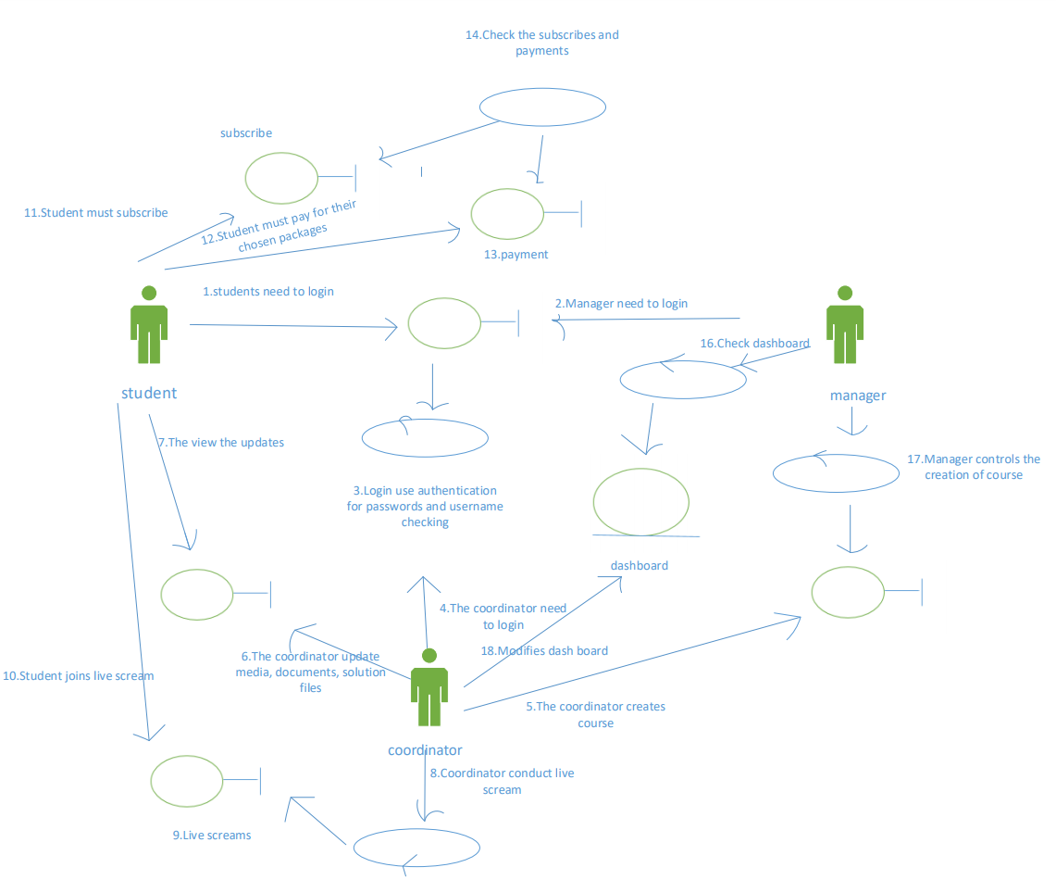

# STATECHART

REGISTER

Provide personal detail

LOGIN

Check authentication

Provide username and password

**STUDENT**

LOGIN

Incorrect Provide username and password

Check authentication

credentials

If correct (if student)

COURSE BAR FOR STUDENT

View course join live scream subscribe view bash board

Choose view course

Choose view bash board

Choose subscribe

Choose join live scream

Choose what give username give username

To view

Choose package payment

press join

view

Solution file and assessments

Uploaded Document and media

p

Watch live screams pay

comment

Send comments

**COURSE COORDINATOR**

LOGIN

Check authentication

Give username and password

Incorrect credentials

If incorrect If correct for course coordinator

COURSE BAR FOR COURSE COORDINATOR

Create course create live scream upload document upload media

Give a course a name

Choose upload media

Choose upload document

Choose create live scream

Give a course a name

Provide material to use put video camera on choose the folder choose folder

Send to the auditor

Choose the document

Choose media

Do the lesson

If approved press finish press upload check if it media

Save video

Upload the course and materials

uploaded

uploaded

Answer upcoming questions

Upload to dash board

**MANAGER**

LOGIN

Incorrect credentials Provide username and password

Check authentication

If incorrect

If correct

COURSE BAR FOR MANAGER

Course auditing managing

Dash board

Choose managing bash board

Choose auditing

Download file from course coordinator opens the dash board

Check quality of information given

Double checking everything in dash board

if not

if not good enough good enough

compliment

Recommend changes

If good standard

Give approval